

**1.Install Keycloak in the EC2 server**

Java is prerequisite required for running keycloak.

apt install openjdk-17-jdk (ubuntu)

Download the ZIP file of the keycloak through the link

<https://github.com/keycloak/keycloak/releases/download/25.0.1/keycloak-25.0.1.zip>

Then extract the downloaded zip file and run the following command to create a self signed certificate and key to access keycloak.

openssl req -newkey rsa:2048 -nodes \  
 -keyout keycloak-server.key.pem -x509 -days 3650 -out keycloak-server.crt.pem



Then add the following environmental variable for default login credentials and to locate the location of the self signed certificate and key in “.bashrc” file.

export KEYCLOAK_ADMIN=admin

export KEYCLOAK_ADMIN_PASSWORD=admin

export KC_HTTPS_CERTIFICATE_FILE=/home/ubuntu/keycloak-server.crt.pem

export KC_HTTPS_CERTIFICATE_KEY_FILE=/home/ubuntu/keycloak-server.key.pem

Start the Keycloak by running the following commands to start it in developer mode.

cd keycloak-25.0.1

bin/kc.sh start-dev > keycloak.log 2>&1 &

Then hit the <https://localhost:8443> to get the Keycloak UI on the browser and enter KEYCLOAK_ADMIN and KEYCLOAK_ADMIN_PASSWORD values to login the Keycloak.

**2.Add the Apps to be secured in Client section**

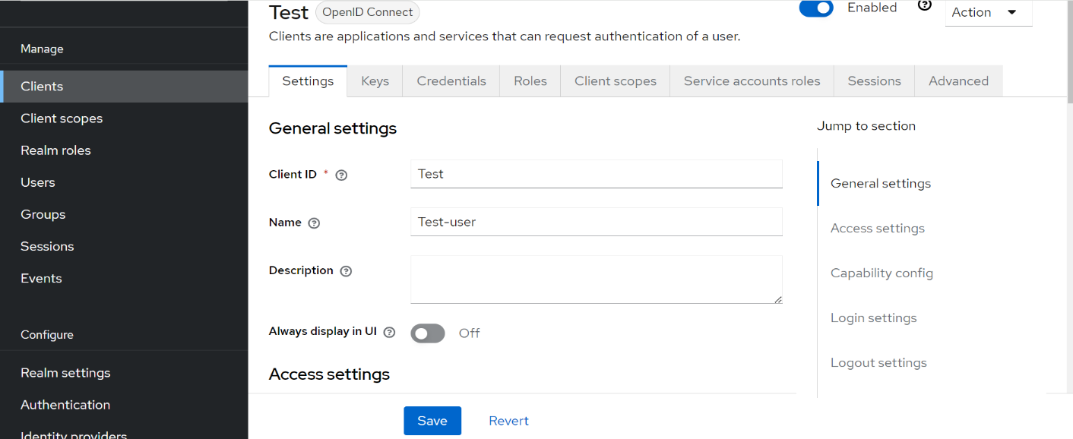Here I am adding two apps namely “Test” and “New” in the client section.

Redirect URL which is used in application code should be added in client access settings.

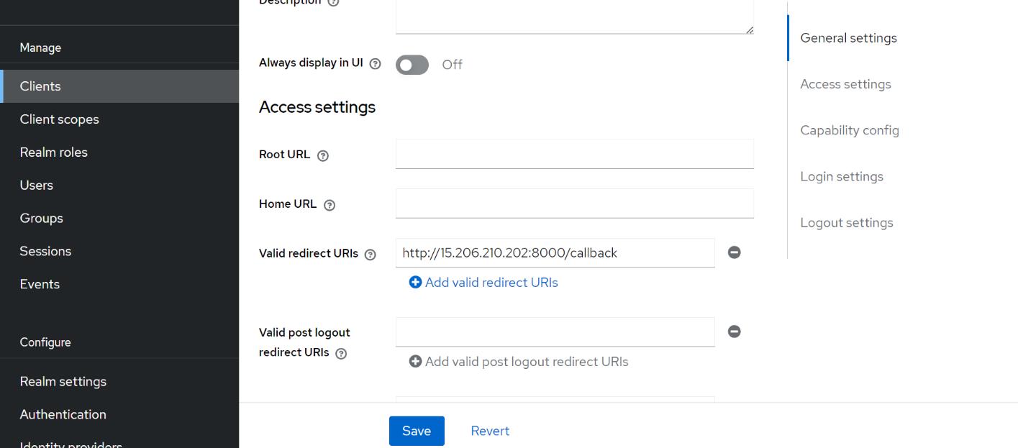

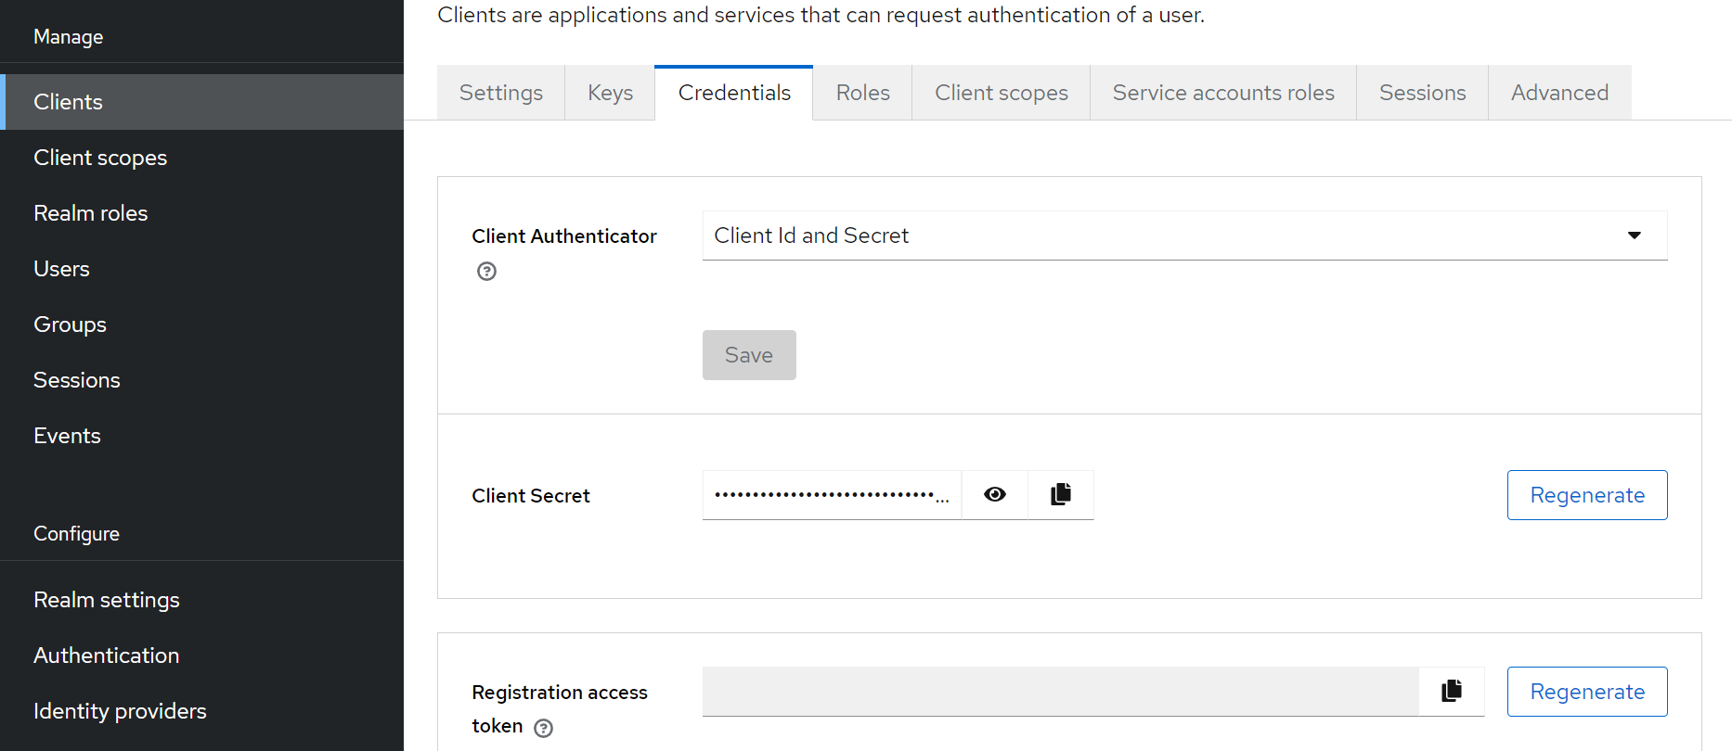

Here Client ID and secret method is used for authentication, this Client Secret will be added in application code for authentication.

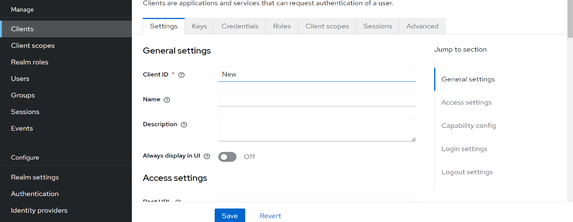The same is done for another application named “New”

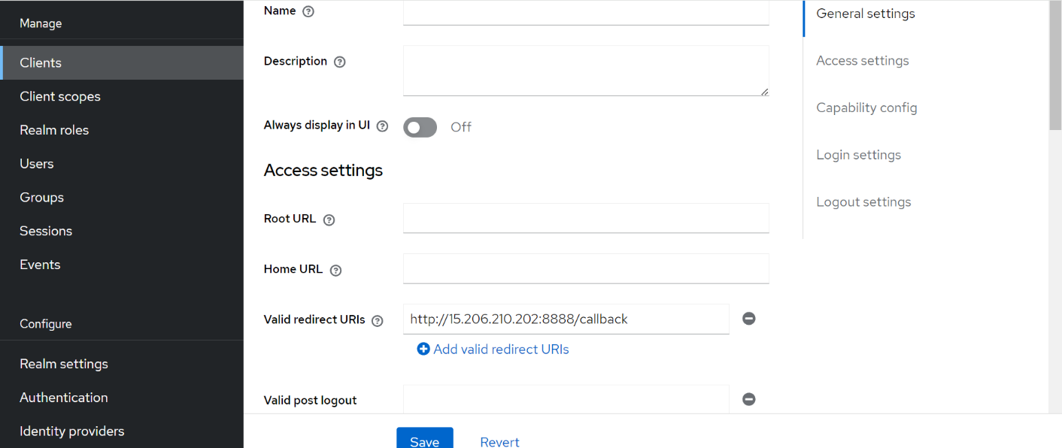

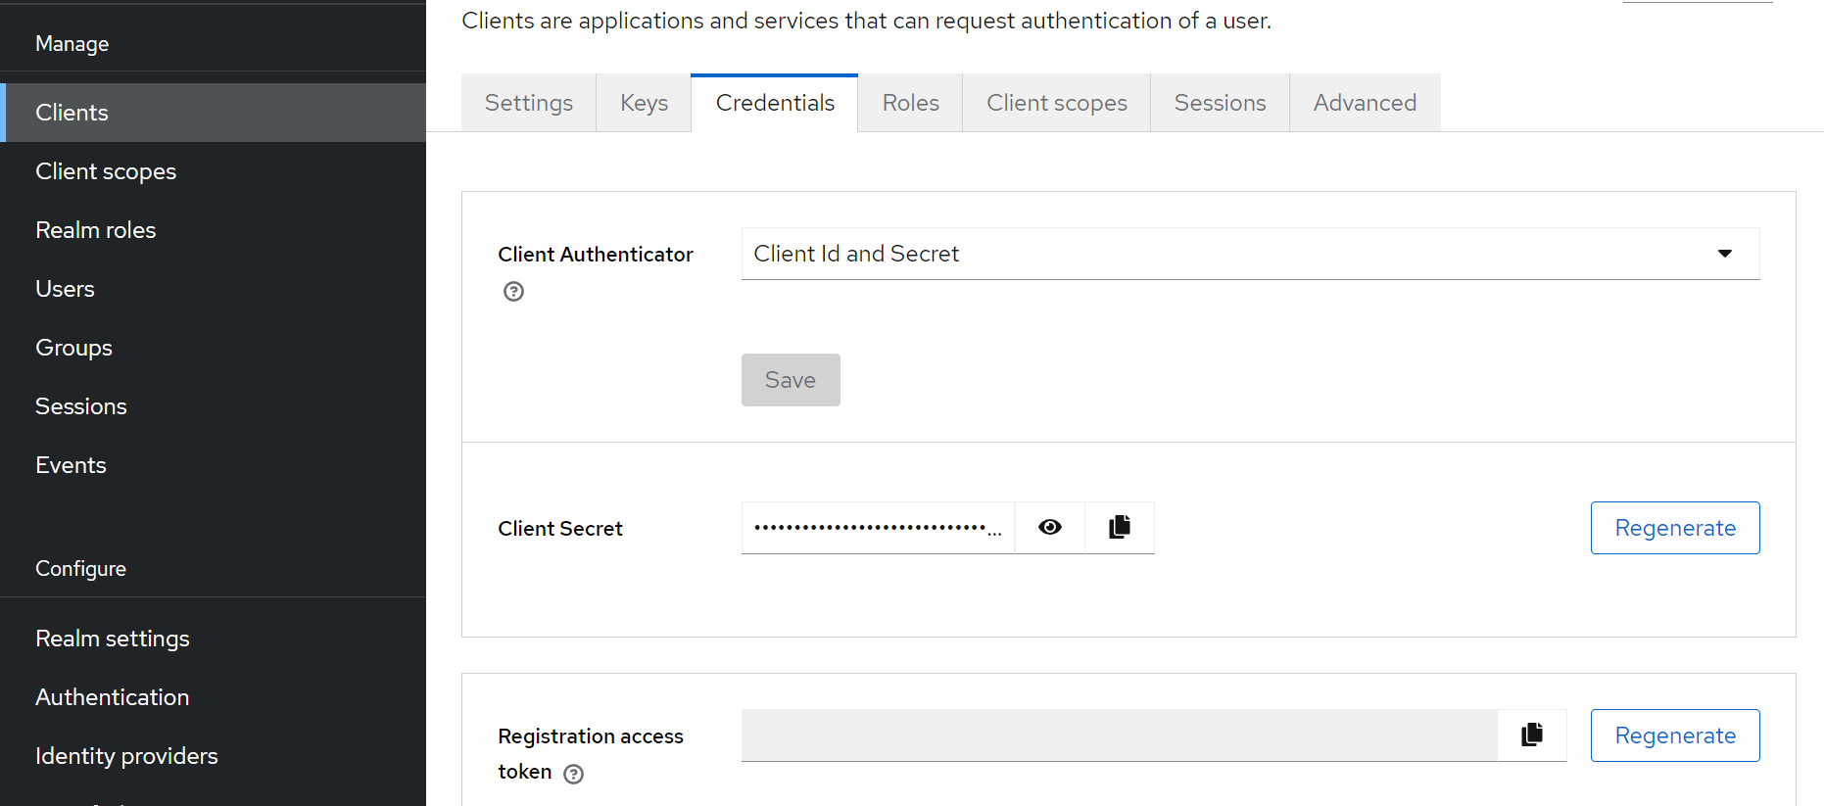

**3.Running the applications**

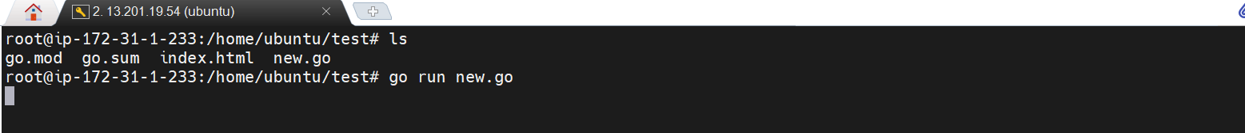Running both go lang applications named “Test” and “New”

Then entering “localhost:8000” and “localhost:8888” in browser for the accessing the applications “Test” and “New” respectively.

Here it can be seen entering <http://13.201.19.54:8000> (Test) automatically redirects to keycloak login page.

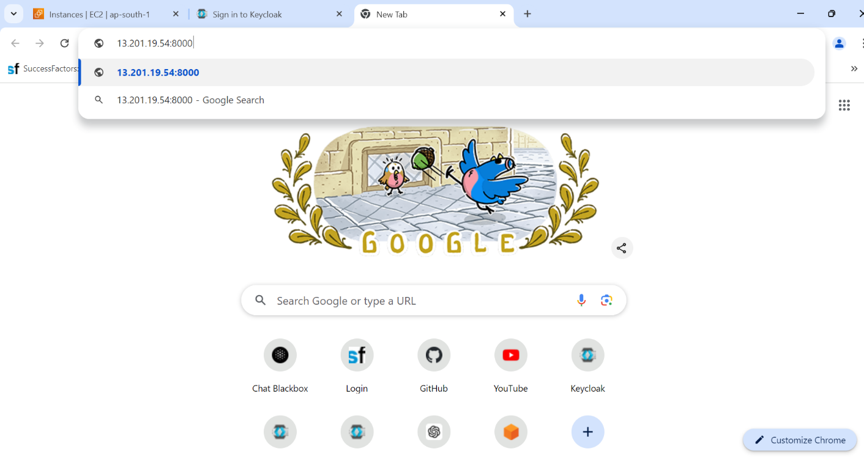

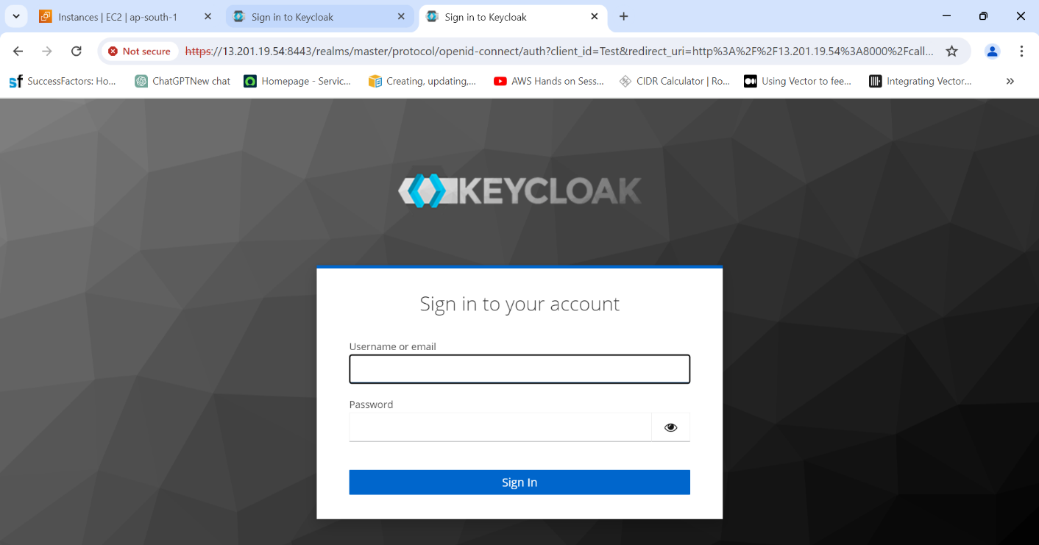

Similarly it can be seen entering <http://13.201.19.54:8888> (New) automatically redirects to keycloak login page.

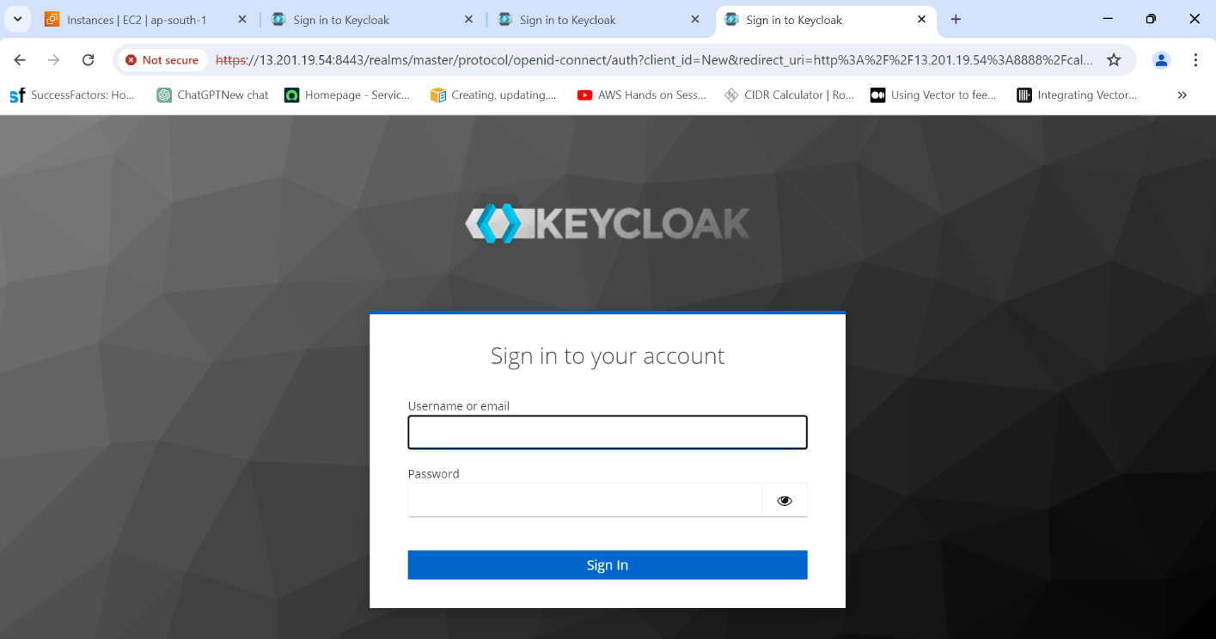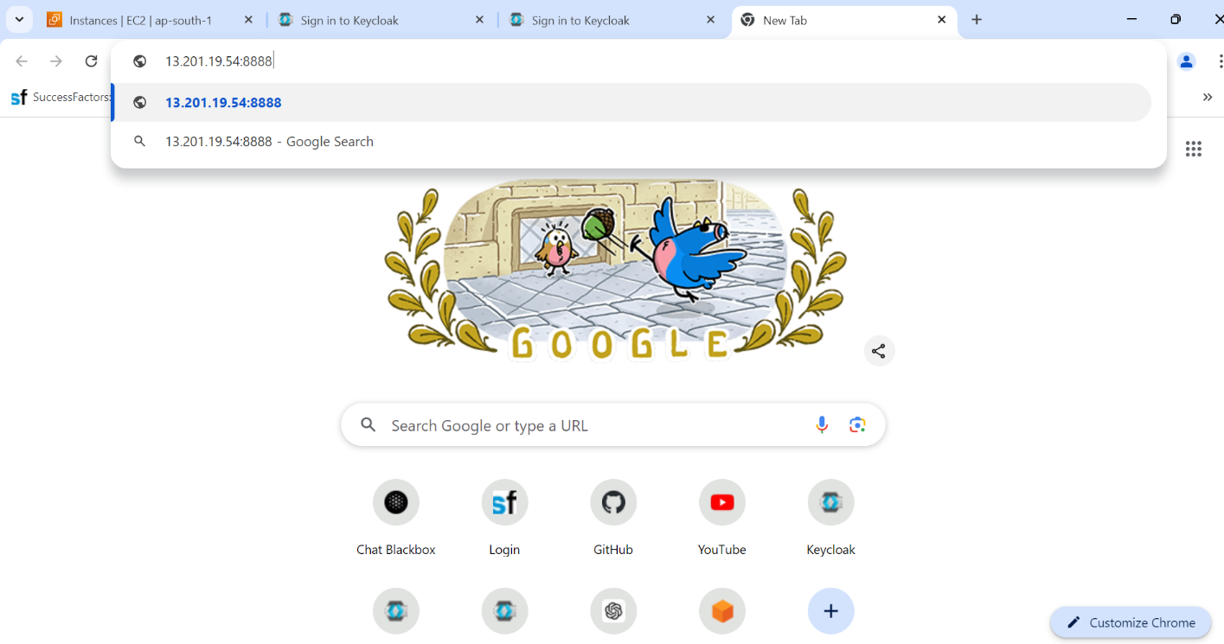

After entering the username and password, the page is redirected using the redirect URL’s given for each application in client section and serves different index.html file for each application.

Logging in single time in any one of the applications automatically logs into the remaining applications and Keycloak also in the name of the Username which is used for logging in. Its because of Single-Sign On (SSO) feature of Keycloak

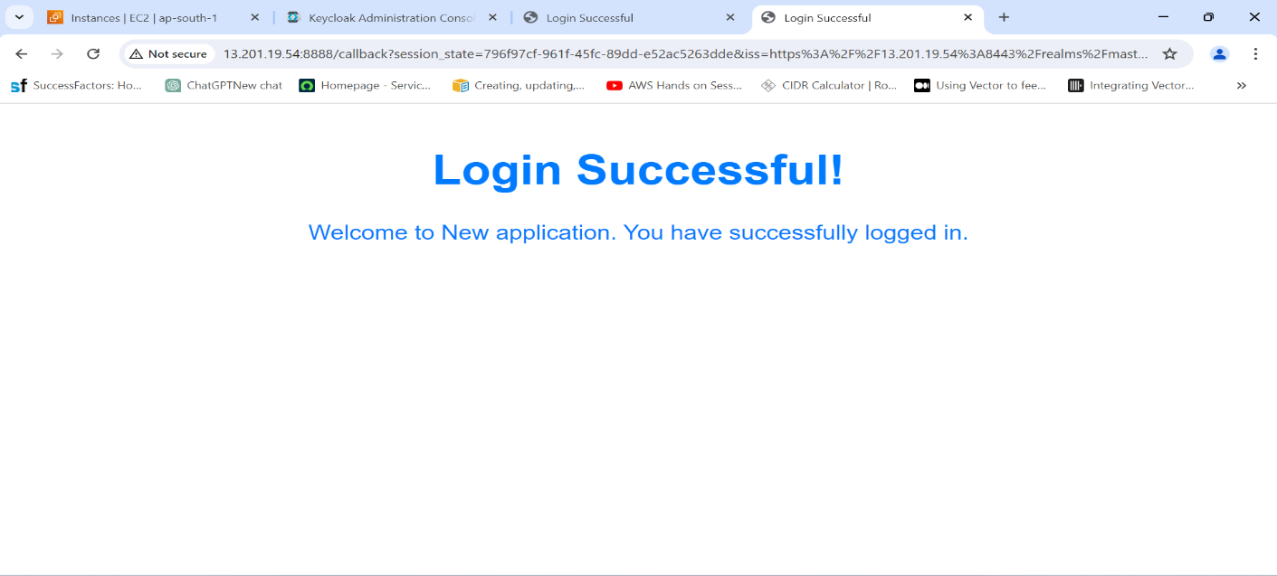

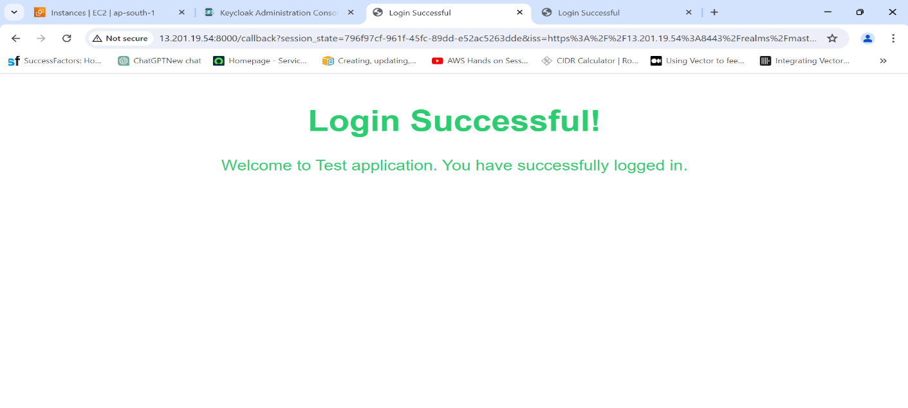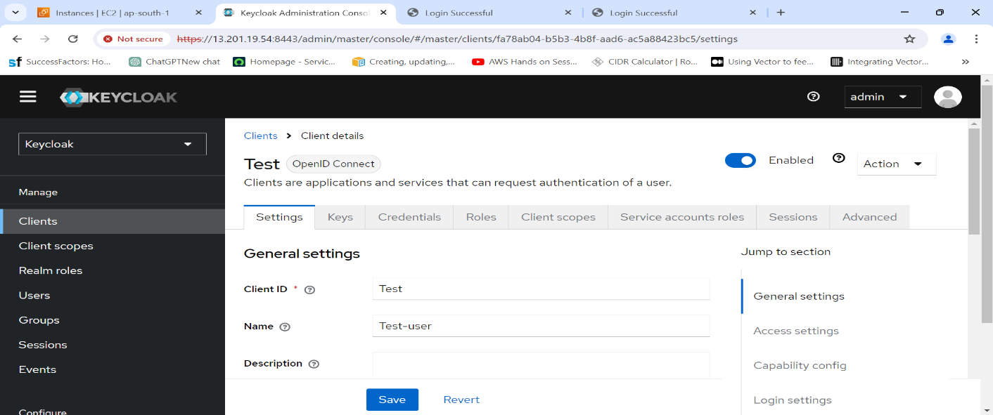

The above demonstration also shows Single-Sign On feature of KeyCloak , when we enter credentials for single application the other application also gets the access token and logs in and shows the output.